**Project Design Phase-II**

**Data Flow Diagram & User Stories**

|  |  |
| --- | --- |
| Date | 03 Nov 2023 |
| Team ID | NM2023TMID04741 |
| Project Name | Retail Management Application Using Salesforce |

**Data Flow Diagrams:**

A Data Flow Diagram (DFD) is a traditional visual representation of the information flows within a system. A neat and clear DFD can depict the right amount of the system requirement graphically. It shows how data enters and leaves the system, what changes the information, and where data is stored.



Example: DFD Level 0 (Industry Standard)

**Example:** [**(Simplified)**](https://developer.ibm.com/patterns/visualize-unstructured-text/)

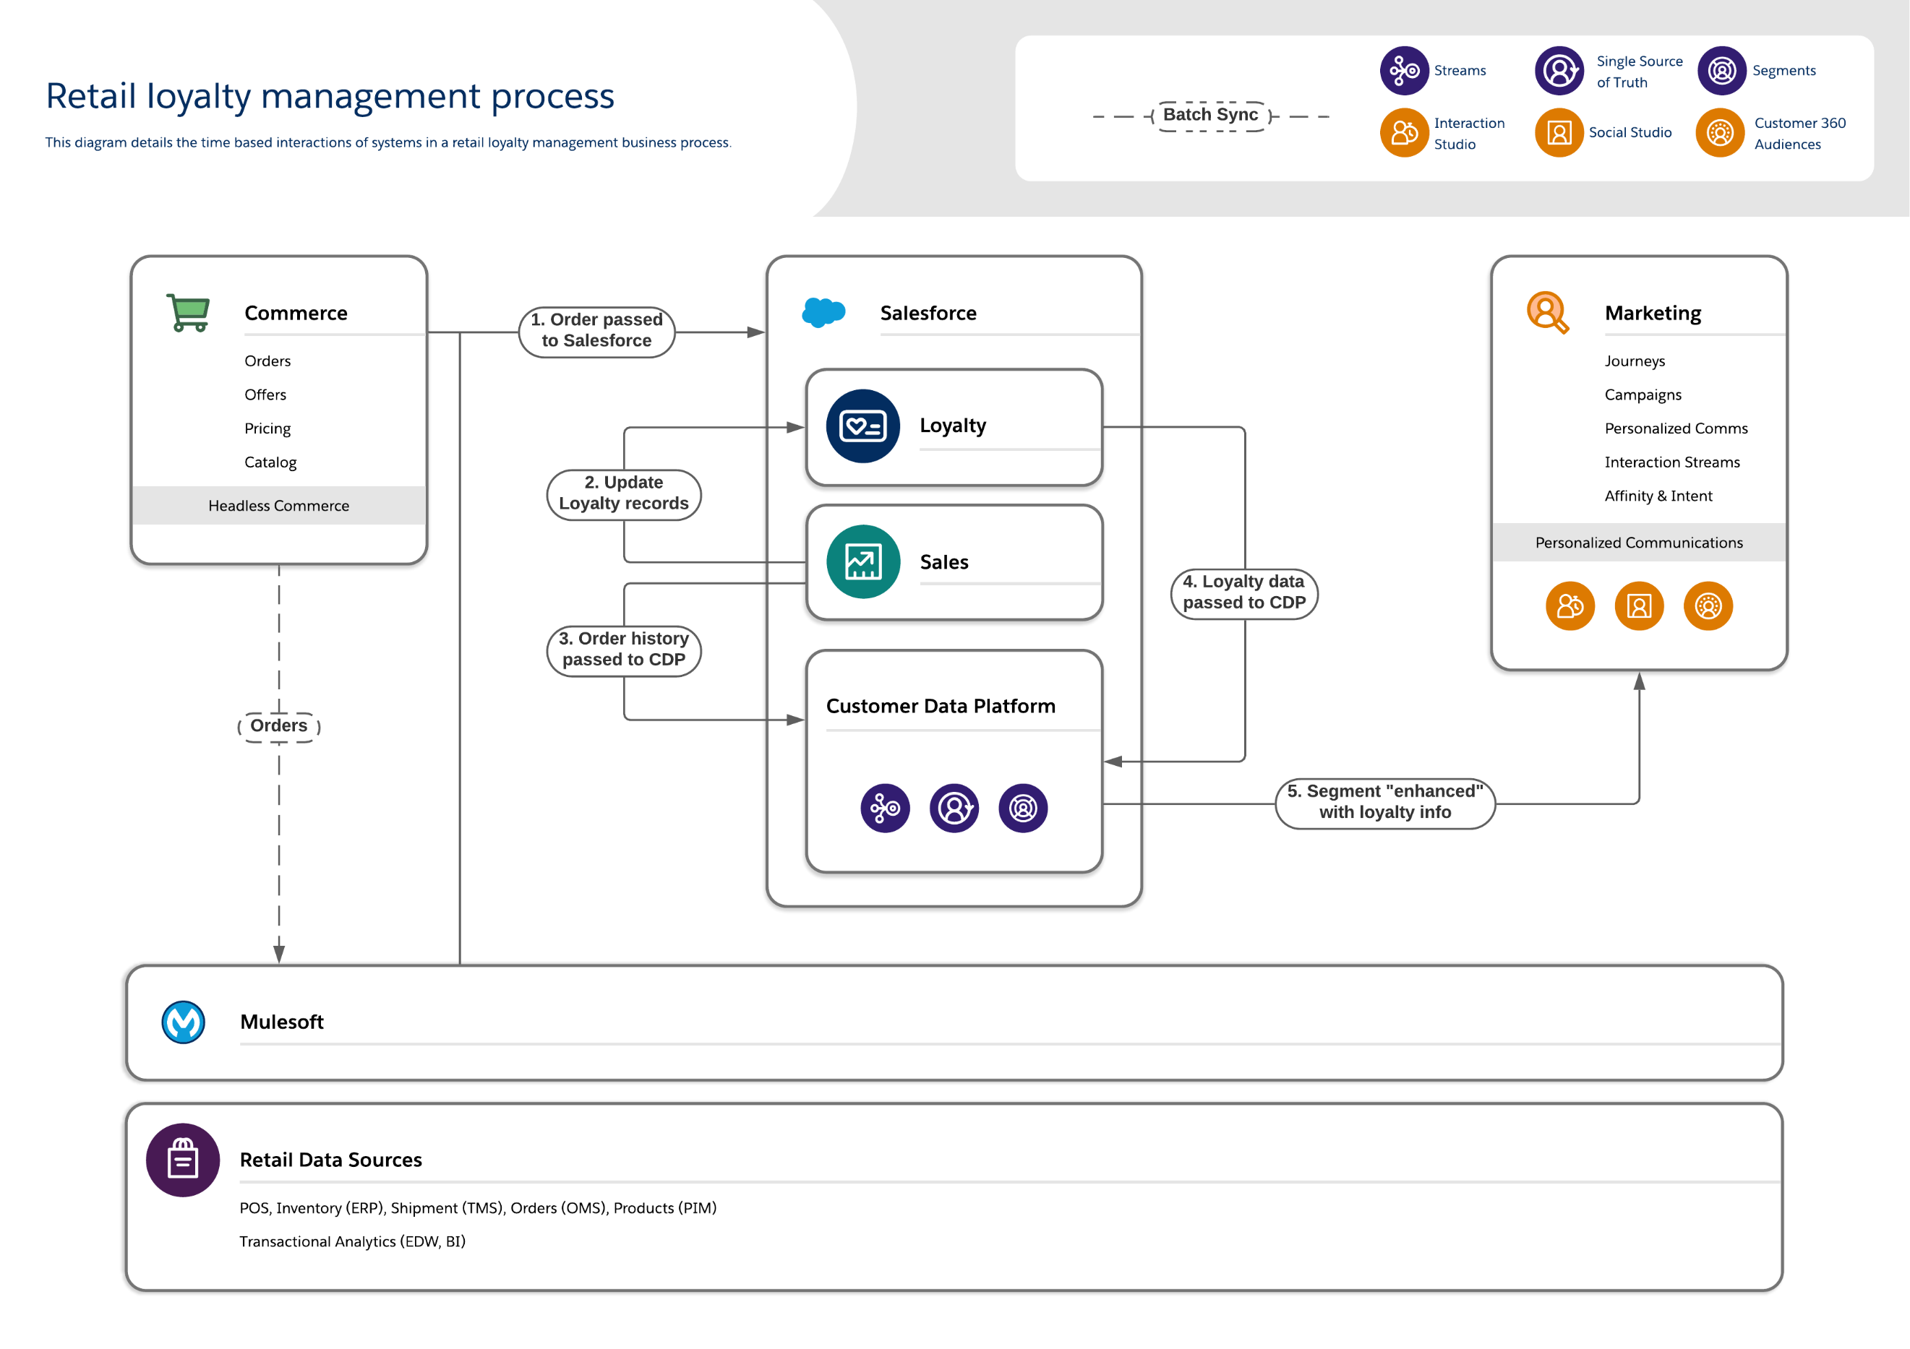

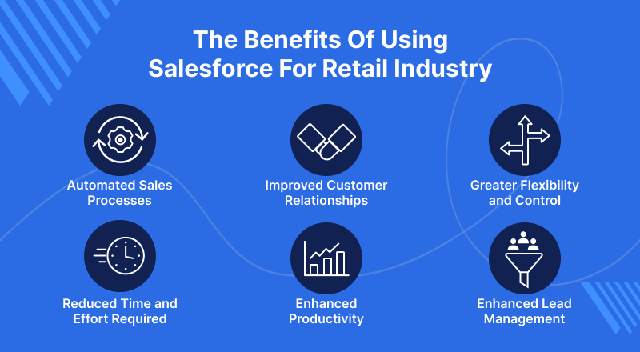

**User Stories**

Use the below template to list all the user stories for the product.

| User Type | Functional Requirement (Epic) | User Story Number | User Story / Task | Acceptance criteria | Priority | Team Member |
| --- | --- | --- | --- | --- | --- | --- |
| Customer (Mobile ) | Image recognition | USN-1 | Salesforce can help you to increase your productivity by helping you to organize and manage your sales data. This enables you to make better decisions faster and improve your overall bottom line. | I should contribute to the sales and promote sustainable management practices. | High | Mohandas |
|  | Classification accuracy | USN-2 | Salesforce allows you to customize the platform to suit your specific needs. This means you can create powerful sales processes and manage your data in a way that is most effective for you. | Salesforce allows you to customize the platform to suit your specific needs. This means you can create powerful sales processes and manage your data in a way that is most effective for you. | High | Thilip kumar |
| Customer (Web user) | Real-time processing | USN-3 | Salesforce is the ultimate sales automation platform for retailers. It allows you to manage your customer relationship management (CRM) data, create powerful sales processes, and track leads and sales activities in real-time. | I can able to process images in real-time and make quick decisions about the type of Salesforce | Low | Mohan |
|  | User interface | USN-4 | In addition to its core sales functionality, Salesforce offers a host of other features that are perfect for retail businesses. These include customer service tools, market analysis tools, supply chain management capabilities, and more. | I should be able to understand the system's operation and receive feedback about their actions. | Medium | Murali |
|  | Integration with other systems | USN-5 | **Enhanced Lead Management:**With Salesforce, you can manage all of your leads in one place, which makes it easier to identify and qualify potential customers. You can also, track the status of your leads and measure your success against targets set by management. | I can view the system functions in the integration model | High | Mohandas |
| Administrator | Data analysis and reporting | USN-6 | The system should be able to analyze data and generate reports that can be used to monitor waste management activities, identify areas for improvement, and make informed decisions. | I can recognize the data set of an project. | Low | Thilip kumar |
|  | Flexibility and scalability | USN-7 | The system should be flexible and scalable to accommodate changing needs and requirements. It should be able to adapt to new types of garbage and be easily upgraded to incorporate new features and capabilities. | The system should be reliable, and its operation should be consistent over time. The system should be able to handle different types of Sales without significant errors or breakdowns. | High | Mohan |
|  |  |  |  |  |  |  |
|  |  |  |  |  |  |  |
|  |  |  |  |  |  |  |
|  |  |  |  |  |  |  |
|  |  |  |  |  |  |  |